**WAP LAB PROGRAM 2**

**INVENTORY MANAGEMENT SYSTEM PORTAL USING HTML5 AND CSS**

**RANJITH KUMAR J**

**RVCE21MCA021**

**I MCA B**

**21/02/2022**

**HOME PAGE**

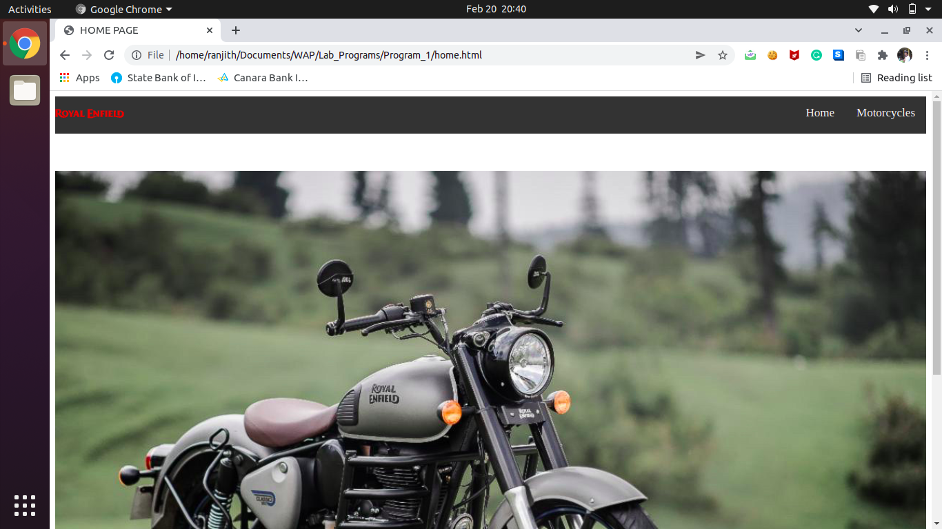

**MOTORCYCLES PAGE**

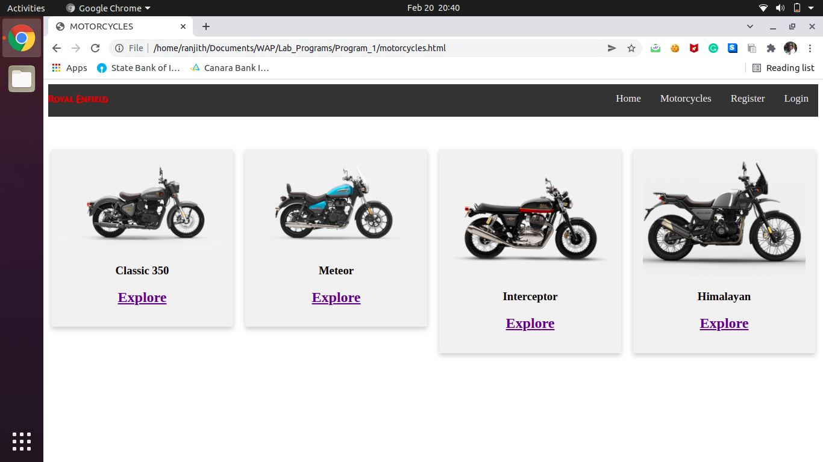

**CLASSIC 350**

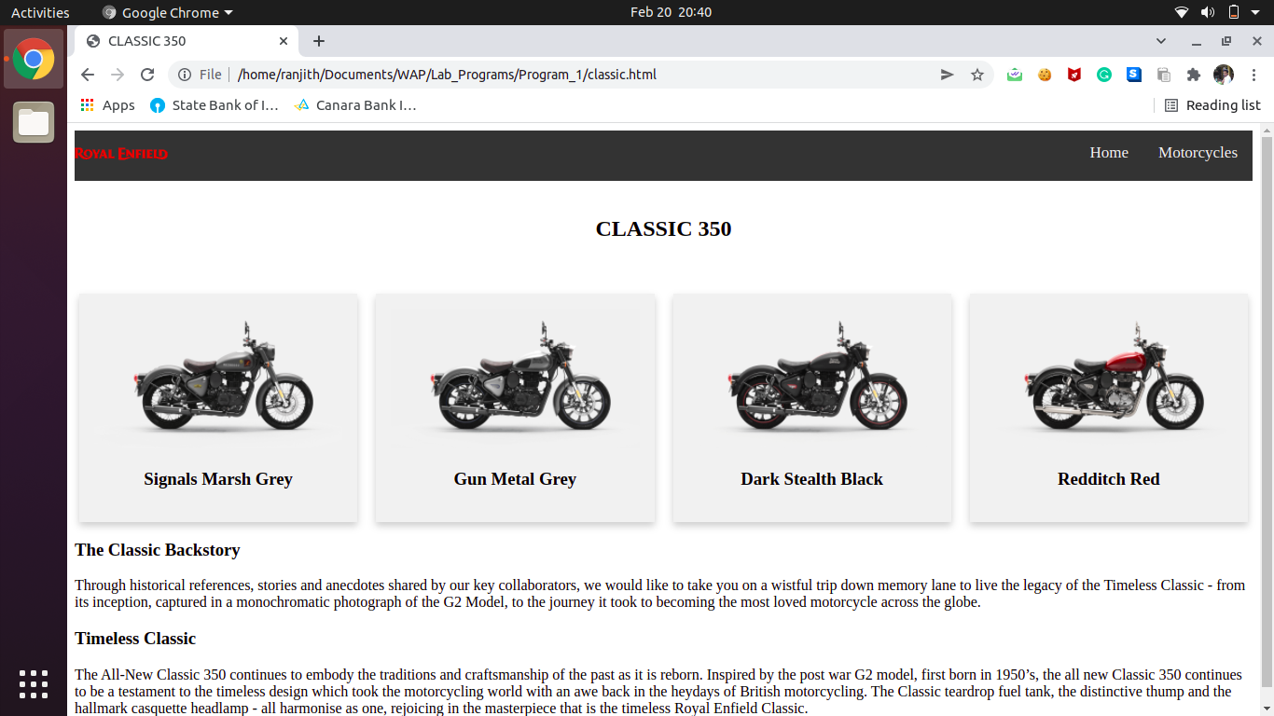

**METEOR**

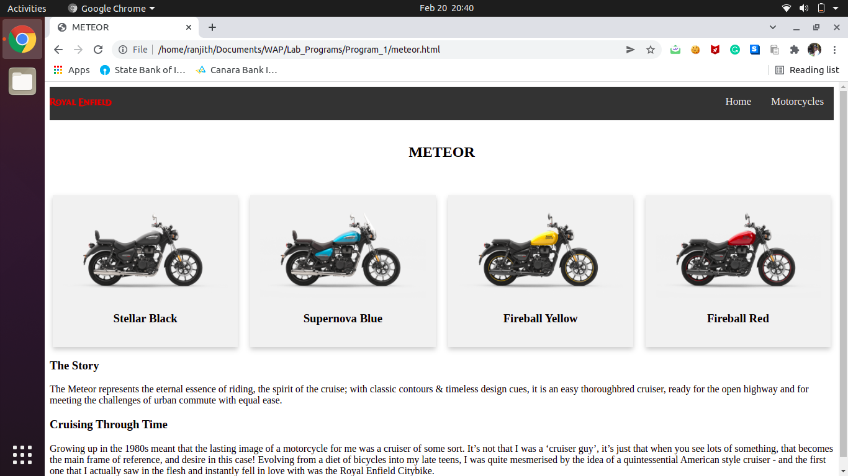

**INTERCEPTOR**

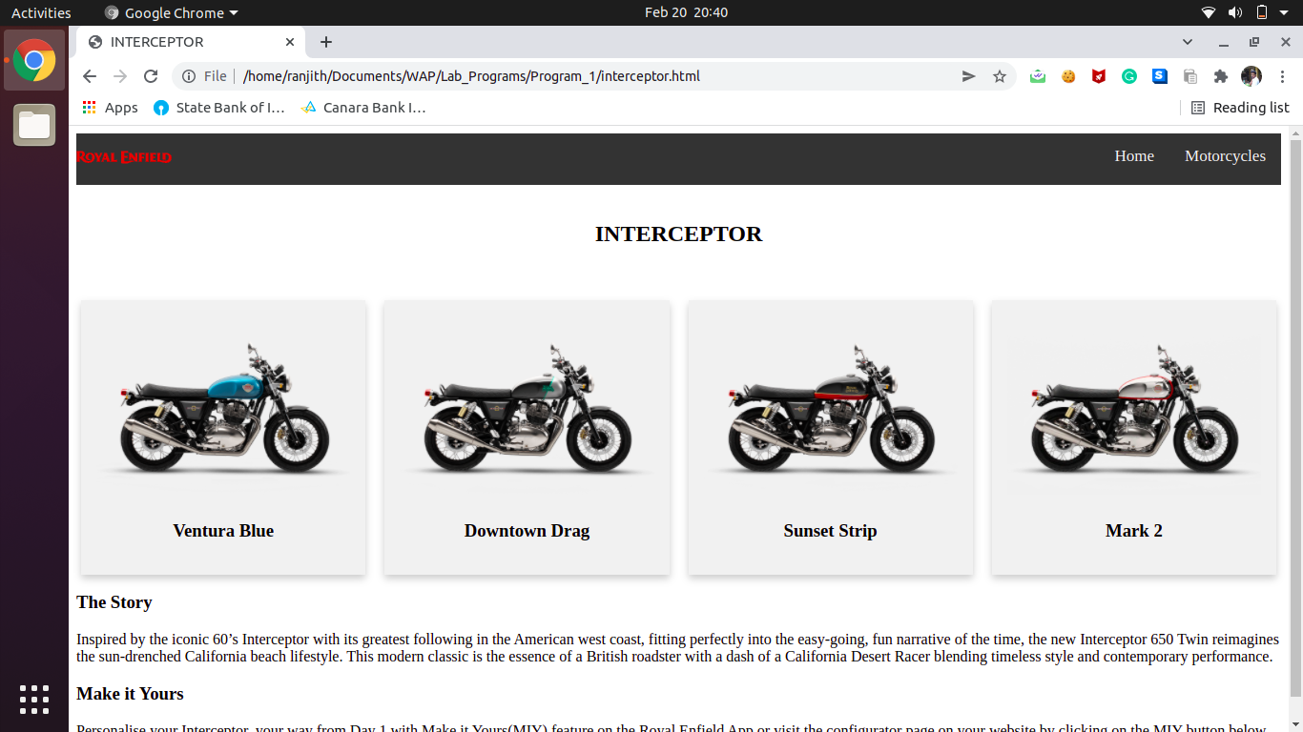

**HIMALAYAN**

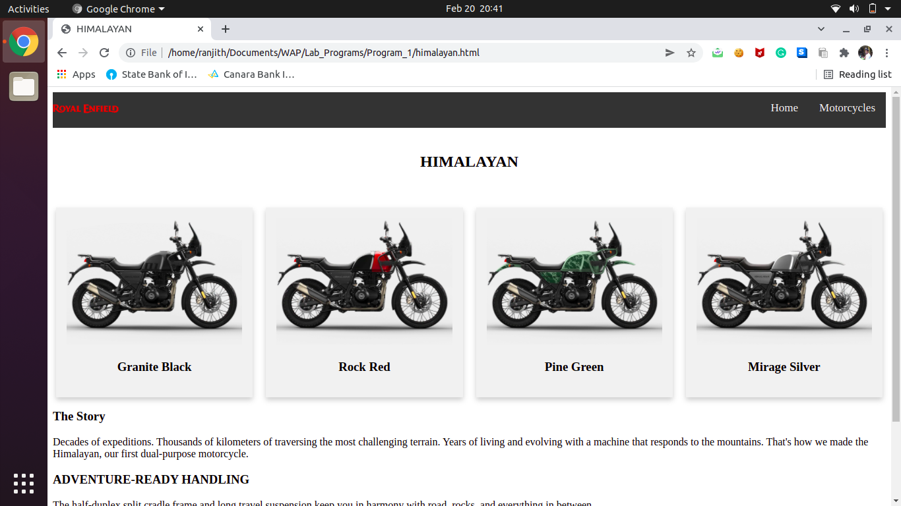

**CODE**

**home.html**

**<!DOCTYPE html>**

**<html>**

**<head>**

**<meta charset="utf-8">**

**<meta name="viewport" content="width=device-width, initial-scale=1">**

**<title>HOME PAGE</title>**

**<link rel="stylesheet" type="text/css" href="style1.css">**

**</head>**

**<body>**

**<div class="topnav">**

**<img src="relogo.svg" float="left" width="100px" height="50px">**

**<a href="motorcycles.html">Motorcycles</a>**

**<a href="home.html">Home</a>**

**</div><br><br><br>**

**<div>**

**<img src="grey.jpg" height="10%" width="100%">**

**</div>**

**</body>**

**</html>**

**motorcycles.html**

**<!DOCTYPE html>**

**<html>**

**<head>**

**<title>MOTORCYCLES</title>**

**<meta name="viewport" content="width=device-width, initial-scale=1">**

**<style>**

**.topnav {**

**overflow: hidden;**

**background-color: #333;**

**}**

**.topnav a {**

**float: right;**

**color: #f2f2f2;**

**text-align: center;**

**padding: 14px 16px;**

**text-decoration: none;**

**font-size: 17px;**

**}**

**\* {**

**box-sizing: border-box;**

**}**

**/* Float four columns side by side */**

**.column {**

**float: left;**

**width: 25%;**

**padding: 0 10px;**

**}**

**/* Remove extra left and right margins, due to padding */**

**.row {margin: 0 -5px;}**

**/* Clear floats after the columns */**

**.row:after {**

**content: "";**

**display: table;**

**clear: both;**

**}**

**/* Responsive columns */**

**@media screen and (max-width: 600px) {**

**.column {**

**width: 100%;**

**display: block;**

**margin-bottom: 20px;**

**}**

**}**

**/* Style the counter cards */**

**.card {**

**box-shadow: 0 4px 8px 0 rgba(0, 0, 0, 0.2);**

**padding: 16px;**

**text-align: center;**

**background-color: #f1f1f1;**

**}**

**</style>**

**</head>**

**<body>**

**<div class="topnav">**

**<img src="relogo.svg" float="left" width="100px" height="50px">**

**<a href="login.html">Login</a>**

**<a href="register.html">Register</a>**

**<a href="motorcycles.html">Motorcycles</a>**

**<a href="home.html">Home</a>**

**</div><br><br><br>**

**<div class="row">**

**<div class="column">**

**<div class="card">**

**<img src="classic.png" style="width:100%">**

**<h3>Classic 350</h3>**

**<h2><a href="classic.html">Explore</a></h2>**

**</div>**

**</div>**

**<div class="column">**

**<div class="card">**

**<img src="meteor.png" style="width:100%">**

**<h3>Meteor</h3>**

**<h2><a href="meteor.html">Explore</a></h2>**

**</div>**

**</div>**

**<div class="column">**

**<div class="card">**

**<img src="interceptor.png" style="width:100%">**

**<h3>Interceptor</h3>**

**<h2><a href="interceptor.html">Explore</a></h2>**

**</div>**

**</div>**

**<div class="column">**

**<div class="card">**

**<img src="himalayan.webp" style="width:100%">**

**<h3>Himalayan</h3>**

**<h2><a href="himalayan.html">Explore</a></h2>**

**</div>**

**</div>**

**</div>**

**</body>**

**</html>**

**classic.html**

**<!DOCTYPE html>**

**<html>**

**<head>**

**<title>CLASSIC 350</title>**

**<meta name="viewport" content="width=device-width, initial-scale=1">**

**<link rel="stylesheet" type="text/css" href="style1.css">**

**</head>**

**<body>**

**<div class="topnav">**

**<img src="relogo.svg" float="left" width="100px" height="50px">**

**<a href="motorcycles.html">Motorcycles</a>**

**<a href="home.html">Home</a>**

**</div><br>**

**<h2 align="center">CLASSIC 350</h2><br><br>**

**<div class="row">**

**<div class="column">**

**<div class="card">**

**<img src="classic.png" style="width:100%">**

**<h3>Signals Marsh Grey</h3>**

**</div>**

**</div>**

**<div class="column">**

**<div class="card">**

**</a><img src="grey.webp" style="width:100%">**

**<h3>Gun Metal Grey</h3>**

**</div>**

**</div>**

**<div class="column">**

**<div class="card">**

**<img src="black.png" style="width:100%">**

**<h3>Dark Stealth Black</h3>**

**</div>**

**</div>**

**<div class="column">**

**<div class="card">**

**<img src="red.png" style="width:100%">**

**<h3>Redditch Red</h3>**

**</div>**

**</div>**

**</div>**

**<div>**

**<h3>The Classic Backstory</h3>**

**<p>Through historical references, stories and anecdotes shared by our key collaborators, we would like to take you on a wistful trip down memory lane to live the legacy of the Timeless Classic - from its inception, captured in a monochromatic photograph of the G2 Model, to the journey it took to becoming the most loved motorcycle across the globe.</p>**

**</div>**

**<div>**

**<h3>Timeless Classic</h3>**

**<p>The All-New Classic 350 continues to embody the traditions and craftsmanship of the past as it is reborn. Inspired by the post war G2 model, first born in 1950’s, the all new Classic 350 continues to be a testament to the timeless design which took the motorcycling world with an awe back in the heydays of British motorcycling. The Classic teardrop fuel tank, the distinctive thump and the hallmark casquette headlamp - all harmonise as one, rejoicing in the masterpiece that is the timeless Royal Enfield Classic.</p>**

**</div>**

**</div>**

**</body>**

**</html>**

**meteor.html**

**<!DOCTYPE html>**

**<html>**

**<head>**

**<title>METEOR</title>**

**<meta name="viewport" content="width=device-width, initial-scale=1">**

**<link rel="stylesheet" type="text/css" href="style1.css">**

**</head>**

**<body>**

**<div class="topnav">**

**<img src="relogo.svg" float="left" width="100px" height="50px">**

**<a href="motorcycles.html">Motorcycles</a>**

**<a href="home.html">Home</a>**

**</div><br>**

**<h2 align="center">METEOR</h2><br><br>**

**<div class="row">**

**<div class="column">**

**<div class="card">**

**<img src="mblack.png" style="width:100%">**

**<h3>Stellar Black</h3>**

**</div>**

**</div>**

**<div class="column">**

**<div class="card">**

**</a><img src="meteor.png" style="width:100%">**

**<h3>Supernova Blue</h3>**

**</div>**

**</div>**

**<div class="column">**

**<div class="card">**

**<img src="myellow.png" style="width:100%">**

**<h3>Fireball Yellow</h3>**

**</div>**

**</div>**

**<div class="column">**

**<div class="card">**

**<img src="mred.png" style="width:100%">**

**<h3>Fireball Red</h3>**

**</div>**

**</div>**

**</div>**

**<div>**

**<h3>The Story</h3>**

**<p>The Meteor represents the eternal essence of riding, the spirit of the cruise; with classic contours & timeless design cues, it is an easy thoroughbred cruiser, ready for the open highway and for meeting the challenges of urban commute with equal ease.</p>**

**</div>**

**<div>**

**<h3>Cruising Through Time</h3>**

**<p>Growing up in the 1980s meant that the lasting image of a motorcycle for me was a cruiser of some sort. It’s not that I was a ‘cruiser guy’, it’s just that when you see lots of something, that becomes the main frame of reference, and desire in this case! Evolving from a diet of bicycles into my late teens, I was quite mesmerised by the idea of a quintessential American style cruiser - and the first one that I actually saw in the flesh and instantly fell in love with was the Royal Enfield Citybike.</p>**

**</div>**

**</div>**

**</body>**

**</html>**

**interceptor.html**

**<!DOCTYPE html>**

**<html>**

**<head>**

**<title>INTERCEPTOR</title>**

**<meta name="viewport" content="width=device-width, initial-scale=1">**

**<link rel="stylesheet" type="text/css" href="style1.css">**

**</head>**

**<body>**

**<div class="topnav">**

**<img src="relogo.svg" float="left" width="100px" height="50px">**

**<a href="motorcycles.html">Motorcycles</a>**

**<a href="home.html">Home</a>**

**</div><br>**

**<h2 align="center">INTERCEPTOR</h2><br><br>**

**<div class="row">**

**<div class="column">**

**<div class="card">**

**<img src="iblue.png" style="width:100%">**

**<h3>Ventura Blue</h3>**

**</div>**

**</div>**

**<div class="column">**

**<div class="card">**

**</a><img src="idd.png" style="width:100%">**

**<h3>Downtown Drag</h3>**

**</div>**

**</div>**

**<div class="column">**

**<div class="card">**

**<img src="interceptor.png" style="width:100%">**

**<h3>Sunset Strip</h3>**

**</div>**

**</div>**

**<div class="column">**

**<div class="card">**

**<img src="im.webp" style="width:100%">**

**<h3>Mark 2</h3>**

**</div>**

**</div>**

**</div>**

**<div>**

**<h3>The Story</h3>**

**<p>Inspired by the iconic 60’s Interceptor with its greatest following in the American west coast, fitting perfectly into the easy-going, fun narrative of the time, the new Interceptor 650 Twin reimagines the sun-drenched California beach lifestyle. This modern classic is the essence of a British roadster with a dash of a California Desert Racer blending timeless style and contemporary performance.</p>**

**</div>**

**<div>**

**<h3>Make it Yours</h3>**

**<p>Personalise your Interceptor, your way from Day 1 with Make it Yours(MIY) feature on the Royal Enfield App or visit the configurator page on your website by clicking on the MIY button below</p>**

**</div>**

**</div>**

**</body>**

**</html>**

**himalayan.html**

**<!DOCTYPE html>**

**<html>**

**<head>**

**<title>HIMALAYAN</title>**

**<meta name="viewport" content="width=device-width, initial-scale=1">**

**<link rel="stylesheet" type="text/css" href="style1.css">**

**</head>**

**<body>**

**<div class="topnav">**

**<img src="relogo.svg" float="left" width="100px" height="50px">**

**<a href="motorcycles.html">Motorcycles</a>**

**<a href="home.html">Home</a>**

**</div><br>**

**<h2 align="center">HIMALAYAN</h2><br><br>**

**<div class="row">**

**<div class="column">**

**<div class="card">**

**<img src="hblack.webp" style="width:100%">**

**<h3>Granite Black</h3>**

**</div>**

**</div>**

**<div class="column">**

**<div class="card">**

**</a><img src="hred.webp" style="width:100%">**

**<h3>Rock Red</h3>**

**</div>**

**</div>**

**<div class="column">**

**<div class="card">**

**<img src="hgreen.webp" style="width:100%">**

**<h3>Pine Green</h3>**

**</div>**

**</div>**

**<div class="column">**

**<div class="card">**

**<img src="himalayan.webp" style="width:100%">**

**<h3>Mirage Silver</h3>**

**</div>**

**</div>**

**</div>**

**<div>**

**<h3>The Story</h3>**

**<p>Decades of expeditions. Thousands of kilometers of traversing the most challenging terrain. Years of living and evolving with a machine that responds to the mountains. That's how we made the Himalayan, our first dual-purpose motorcycle.</p>**

**</div>**

**<div>**

**<h3>ADVENTURE-READY HANDLING</h3>**

**<p>The half-duplex split cradle frame and long travel suspension keep you in harmony with road, rocks, and everything in between.</p>**

**</div>**

**<div>**

**<h3>VERSATILE PERFORMANCE</h3>**

**<p>800mm seat height, perfectly positioned footpegs and handlebars reduce fatigue and give you a comfortable upright riding position whether you sit or stand.<p>**

**</div>**

**</div>**

**</body>**

**</html>**

**style1.css**

**.topnav {**

**overflow: hidden;**

**background-color: #333;**

**}**

**.topnav a {**

**float: right;**

**color: #f2f2f2;**

**text-align: center;**

**padding: 14px 16px;**

**text-decoration: none;**

**font-size: 17px;**

**}**

**\* {**

**box-sizing: border-box;**

**}**

**.column {**

**float: left;**

**width: 25%;**

**padding: 0 10px;**

**}**

**.row {margin: 0 -5px;}**

**.row:after {**

**content: "";**

**display: table;**

**clear: both;**

**}**

**@media screen and (max-width: 600px) {**

**.column {**

**width: 100%;**

**display: block;**

**margin-bottom: 20px;**

**}**

**}**

**.card {**

**box-shadow: 0 4px 8px 0 rgba(0, 0, 0, 0.2);**

**padding: 16px;**

**text-align: center;**

**background-color: #f1f1f1;**

**}**